Machine Learning – Classification Assignment
Random Forest Classifier
- What is the percentage of correct classification of both (Purchased and Not Purchased) to the total input of the test set? 0.92
- What is the percentage of correct classification of (Purchased) to the total input of (Purchased) in the test set? 0.93
- What is the percentage of correct classification of(Not Purchased) to the total input of (Not Purchased) in the test set? 0.91
- What is the percentage of correct classification of (Purchased) to sum of correctly classified as Purchased and wrongly classified as Purchased in the test set? 0.84
- What is the percentage of correct classification of (Not Purchased) to sum of correctly classified as Not Purchased and wrongly classified as Not Purchased in the test set?0.96
- What is the overall performance of Purchased?0.88
- What is the overall performance of Not Purchased?0.94
- What if the recall value is high and Precision value is low. How will you validate your model performance? – Recall value is 0.91 for Not purchased and Precision value is 0.96, For Purchased Recall value is 0.93 and Precision is 0.84, when comparing to below SVMC and DCT classifier, Random Forest gives the nearest value to 1 and hence this model can be deployed.
- What is the average performance of Precision (Correctly and wrongly classified)? 0.90
- What is the average performance of Recall (Correctly and wrongly classified)? 0.92
- What is the average performance of F1 measure (Correctly and wrongly classified)? 0.91
- What is the sum of product of proportion rate (Weight) of each class? 0.92
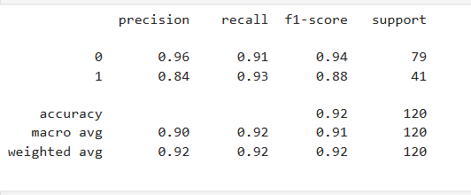

Decision Tree Classifier
- What is the percentage of correct classification of both (Purchased and Not Purchased) to the total input of the test set? 0.89
- What is the percentage of correct classification of (Purchased) to the total input of (Purchased) in the test set? 0.83
- What is the percentage of correct classification of(Not Purchased) to the total input of (Not Purchased) in the test set? 0.92
- What is the percentage of correct classification of (Purchased) to sum of correctly classified as Purchased and wrongly classified as Purchased in the test set? 0.85
- What is the percentage of correct classification of (Not Purchased) to sum of correctly classified as Not Purchased and wrongly classified as Not Purchased in the test set? 0.91
- What is the overall performance of Purchased? 0.84
- What is the overall performance of Not Purchased? 0.92
- What if the recall value is high and Precision value is low. How will you validate your model performance? - Recall value is 0.92 for Not purchased and Precision value is 0.91, For Purchased Recall value is 0.83 and Precision is 0.85, hence this model is not giving proper prediction
- What is the average performance of Precision (Correctly and wrongly classified)? 0.88
- What is the average performance of Recall (Correctly and wrongly classified)? 0.88
- What is the average performance of F1 measure (Correctly and wrongly classified)? 0.88
- What is the sum of product of proportion rate (Weight) of each class? 0.89
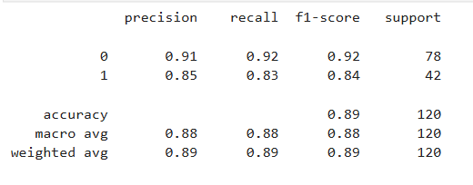

Support Vector Machine Classifier
- What is the percentage of correct classification of both (Purchased and Not Purchased) to the total input of the test set? 0.79
- What is the percentage of correct classification of (Purchased) to the total input of (Purchased) in the test set? 0.44
- What is the percentage of correct classification of(Not Purchased) to the total input of (Not Purchased) in the test set? 0.97
- What is the percentage of correct classification of (Purchased) to sum of correctly classified as Purchased and wrongly classified as Purchased in the test set? 0.90
- What is the percentage of correct classification of (Not Purchased) to sum of correctly classified as Not Purchased and wrongly classified as Not Purchased in the test set? 0.77
- What is the overall performance of Purchased? 0.59
- What is the overall performance of Not Purchased? 0.86
- What if the recall value is high and Precision value is low. How will you validate your model performance? - Recall value is 0.97 for Not purchased and Precision value is 0.77, For Purchased Recall value is 0.44 and Precision is 0.90, hence this model is not giving proper prediction
- What is the average performance of Precision (Correctly and wrongly classified)? 0.83
- What is the average performance of Recall (Correctly and wrongly classified)? 0.71
- What is the average performance of F1 measure (Correctly and wrongly classified)? 0.73
- What is the sum of product of proportion rate (Weight) of each class? Precision is 0.81, Recall is 0.79, F1 score is 0.77
